**Pagination in JavaScript**

**TWBS Pagination Library**

***Twbs Pagination*** is a jQuery & Bootstrap powered pagination plugin which allows you to page the long text content for better readability.

Currently supports the latest Bootstrap 4 and Bootstrap 3 frameworks.

**How to use it:**

**1.** Load the Bootstrap's stylesheet in the header of the document. You can also use your styles for pagination.



**2.** Load the jQuery JavaScript library and the jQuery Twbs Pagination plugin at the end of the document.

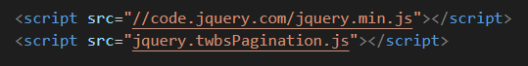

**3.** Create an empty Html list in the document and the plugin will generate customizable pagination using ***<li>*** elements.



**4.** Call the plugin on the Html list and set the options for the pagination.

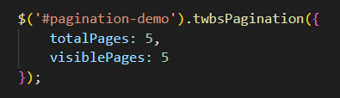

**5.** All the default options are shown below:

